**Training Phase:**

Step 1: Data Preprocessing

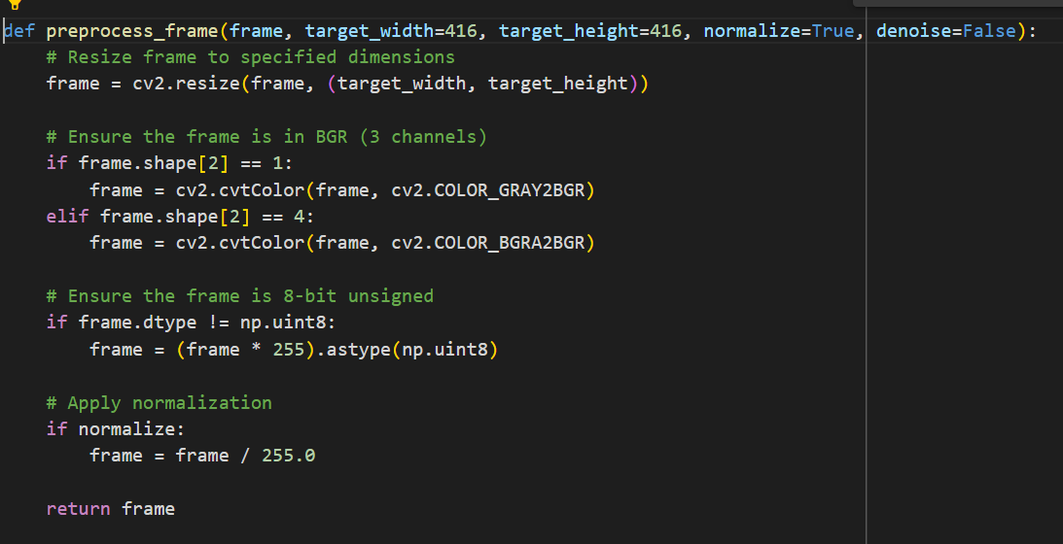

Step 2: Load YOLO Model and Prepare Data

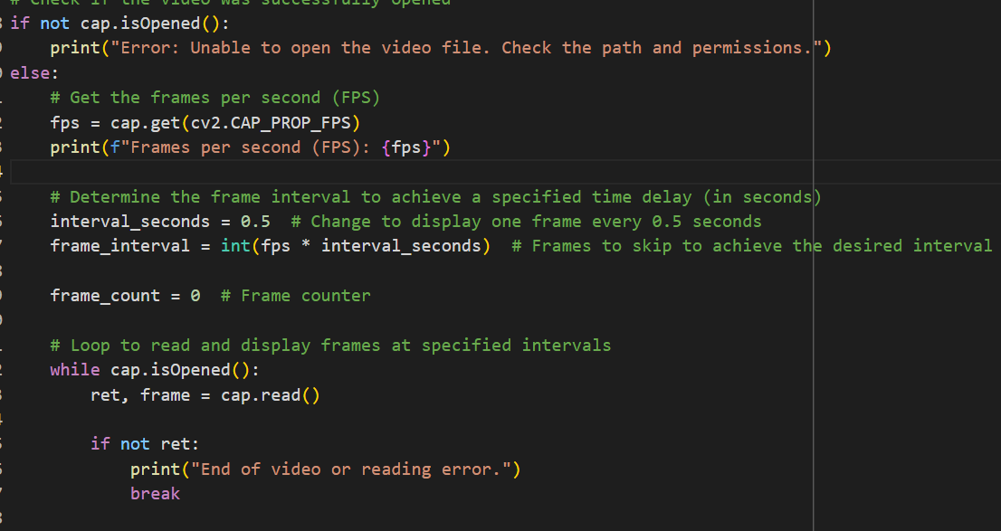

Step 3: Person detection with YOLO:

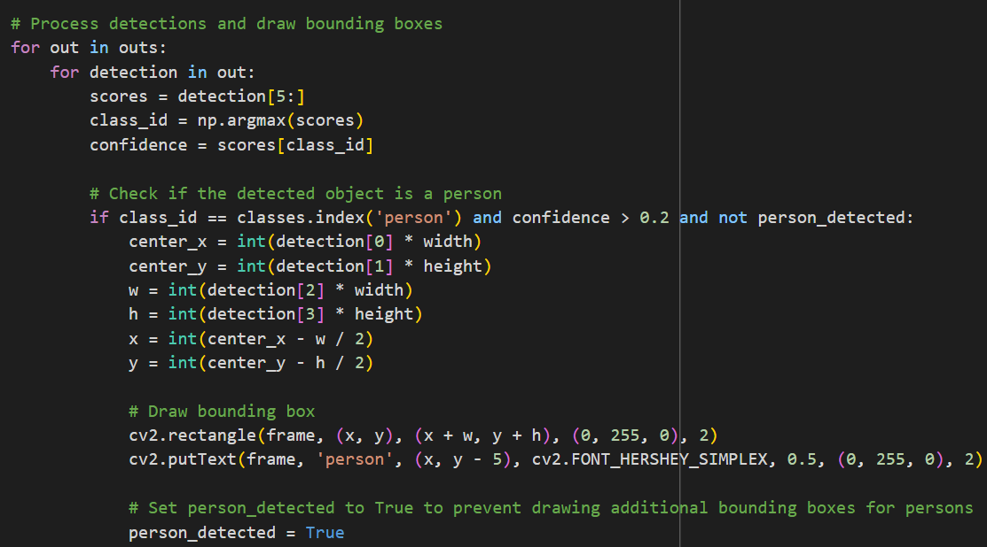

Prediction Phase:

Step 1: Load Pre-trained Models

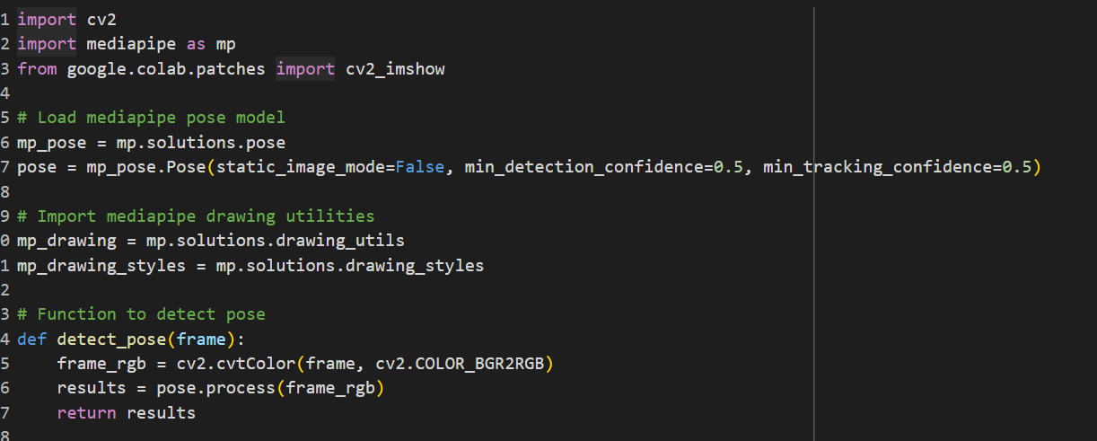

Step 2: Process Video Frames

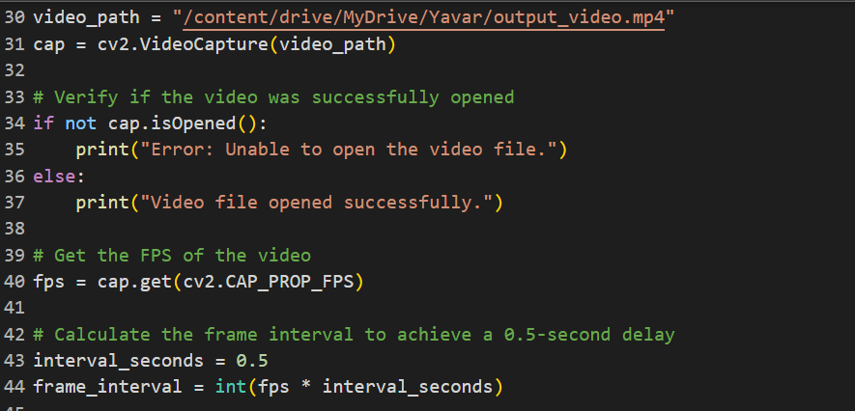

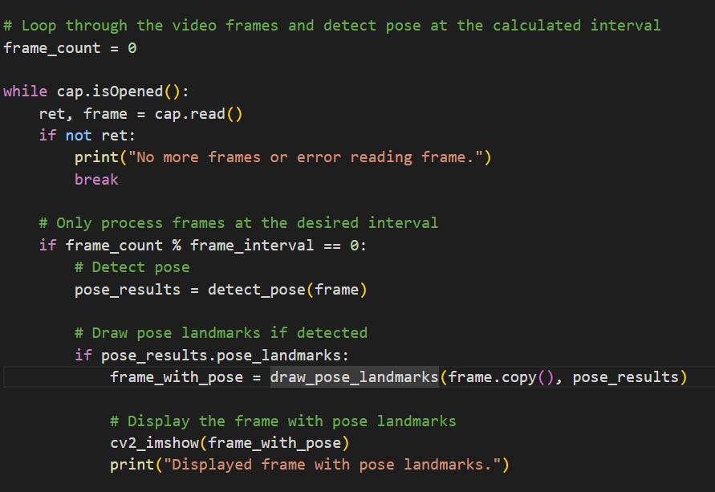

Step 3: Display Results

